UPDATED 5/9/15

There are some things I updated:

* My wireframes were good in theory, but as I made it in HTML, it was increasingly diffcult to exactly construct them. Therefore, my actual pages were changed to aestetically and functionally improve my website.
* My location changed to Texas. I originally estimated NYC or some expensive location, but I soon found out it was unrealistic. Therefore, I found a higher class part of texas at an affordable rate, and chose there to be my business’s location.
* Other subtle changes can also be noted, but overall, my website is more-or-less the same. Any changes were either necessary or found to be helpful.

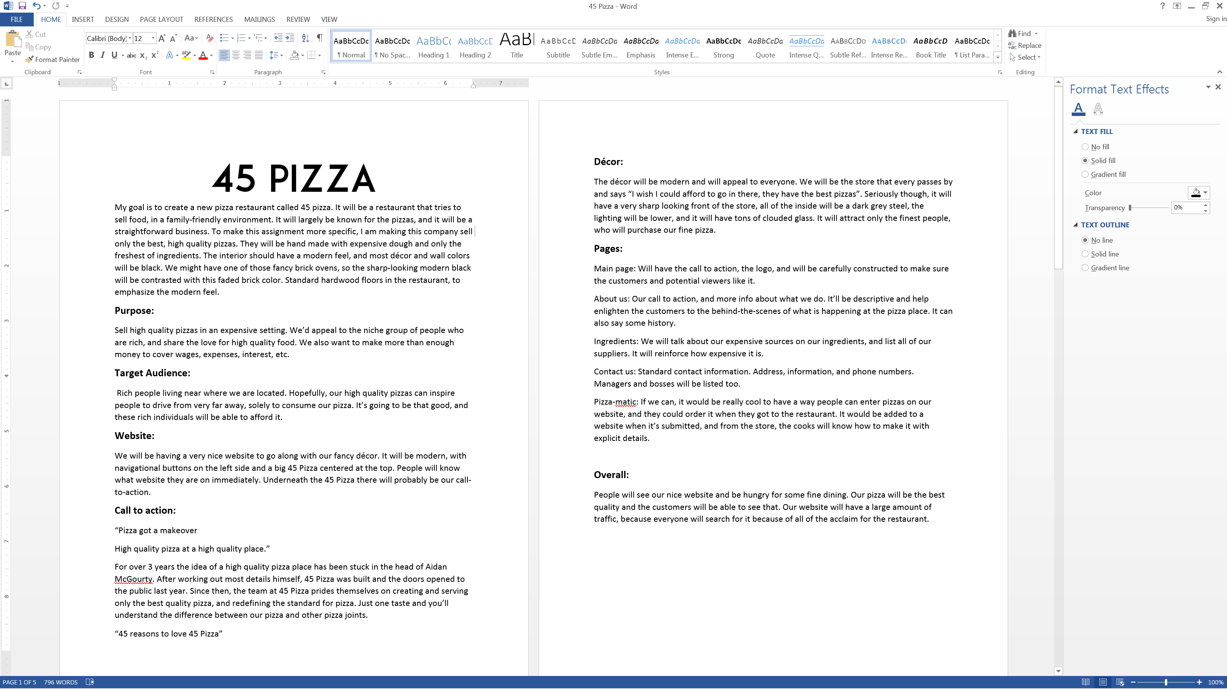

My goal is to create a new pizza restaurant called 45 pizza. It will be a restaurant that tries to sell food, in a family-friendly environment. It will largely be known for the pizzas, and it will be a straightforward business. To make this assignment more specific, I am making this company sell only the best, high quality pizzas. They will be hand made with expensive dough and only the freshest of ingredients. The interior should have a modern feel, and most décor and wall colors will be black. We might have one of those fancy brick ovens, so the sharp-looking modern black will be contrasted with this faded brick color. Standard hardwood floors in the restaurant, to emphasize the modern feel.

**Purpose:**

Sell high quality pizzas in an expensive setting. We’d appeal to the niche group of people who are rich, and share the love for high quality food. We also want to make more than enough money to cover wages, expenses, interest, etc.

**Target Audience:**

Rich people living near where we are located. Hopefully, our high quality pizzas can inspire people to drive from very far away, solely to consume our pizza. It’s going to be that good, and these rich individuals will be able to afford it.

**Website:**

We will be having a very nice website to go along with our fancy décor. It will be modern, with navigational buttons on the left side and a big 45 Pizza centered at the top. People will know what website they are on immediately. Underneath the 45 Pizza there will probably be our call-to-action.

**Call to action:**

“Pizza got a makeover

High quality pizza at a high quality place.”

For over 3 years the idea of a high quality pizza place has been stuck in the head of Aidan McGourty. After working out most details himself, 45 Pizza was built and the doors opened to the public last year. Since then, the team at 45 Pizza prides themselves on creating and serving only the best quality pizza, and redefining the standard for pizza. Just one taste and you’ll understand the difference between our pizza and other pizza joints.

“45 reasons to love 45 Pizza”

**Décor:**

The décor will be modern and will appeal to everyone. We will be the store that every passes by and says “I wish I could afford to go in there, they have the best pizzas”. Seriously though, it will have a very sharp looking front of the store, all of the inside will be a dark grey steel, the lighting will be lower, and it will have tons of clouded glass. It will attract only the finest people, who will purchase our fine pizza.

**Pages:**

Main page: Will have the call to action, the logo, and will be carefully constructed to make sure the customers and potential viewers like it.

About us: Our call to action, and more info about what we do. It’ll be descriptive and help enlighten the customers to the behind-the-scenes of what is happening at the pizza place. It can also say some history.

Ingredients: We will talk about our expensive sources on our ingredients, and list all of our suppliers. It will reinforce how expensive it is.

Contact us: Standard contact information. Address, information, and phone numbers. Managers and bosses will be listed too.

Pizza-matic: If we can, it would be really cool to have a way people can enter pizzas on our website, and they could order it when they got to the restaurant. It would be added to a website when it’s submitted, and from the store, the cooks will know how to make it with explicit details.

**Overall:**

People will see our nice website and be hungry for some fine dining. Our pizza will be the best quality and the customers will be able to see that. Our website will have a large amount of traffic, because everyone will search for it because of all of the acclaim for the restaurant.



About us

Contact us

Ingredients

Main page

Pizza-matic

Main page^

About us \/

Text, descriptive information about us

About us

Contact us

Ingredients

Main page

Pizza-matic



About us

Contact us

Ingredients

Main page

Pizza-matic

Ingredients^

Contact us \/

Text, descriptive information about us

About us

Contact us

Ingredients

Main page

Pizza-matic

It will look nearly identical to the about us page. It just has to house some text.



A specific java or HTML5 application that users can enter info into about their optimal pizza.

About us

Contact us

Ingredients

Main page

Pizza-matic

Instructions/information

I just hope I did this correctly, I’m very sorry if I forgot something or I did these wireframes wrong. If something needs changing or I completely messed this up, I’ll gladly redo it.

Thank you!

Aidan McGourty